C++ Test Framework
Users Guide

Last Saved On: 11/8/26 4:58 AM

Revision History
Date: | Version: | Description: | Author:
01/23/03 | 1.0 | Initial Draft | John Bramlett

Table Of Contents
Table Of Contents 4
Introduction 1
Configuration Options 1
Using the Service 4
DBPool 6
DBConnectionPtr 7
DBConnection (and specialization OracleConnection) 8
Underlying Database Connection 9
Extending the Service 10
Subclass DBConnection 10
Incorporate with DBConnectionFactory 10
Appendix A: C++ Database Connection Pool Manifest 11
Independent Classes 11
C++ Database Connection Pool Classes 12

Introduction
One of the key elements of a successful software development project is good testing. To this end software methodologies (especially those based on agile software development principles) are stressing the development, maintenance, and constant execution of programmatic unit testing. In the Java a framework called JUnit has become the defacto standard for developing these programmatic unit tests. However, there does not seem to be such a framework available for C++ development. There is a “port” of JUnit to C++ (called CPPUnit available from sourceforge.net) but after investigating this framework, its complexity, and the prospect of porting this between Windows and HP-UX I decided to go another route and develop my own.

The goal was to develop a framework that provide a common facility for developing and executing unit tests in C++ that was easily portable to across platforms. To this end, the C++ Test Framework was development. This framework relies heavily on the use of C++ templates to provide the dynamic functionality easily available in Java through reflection.

The framework is lightweight (there are only 2 classes, 2 templates, and 1 “interface” – and the total number of methods across all of these classes very low as well) but provides the basic functionality offered through JUnit. Figure 1 provides class model of the classes that make up the framework.

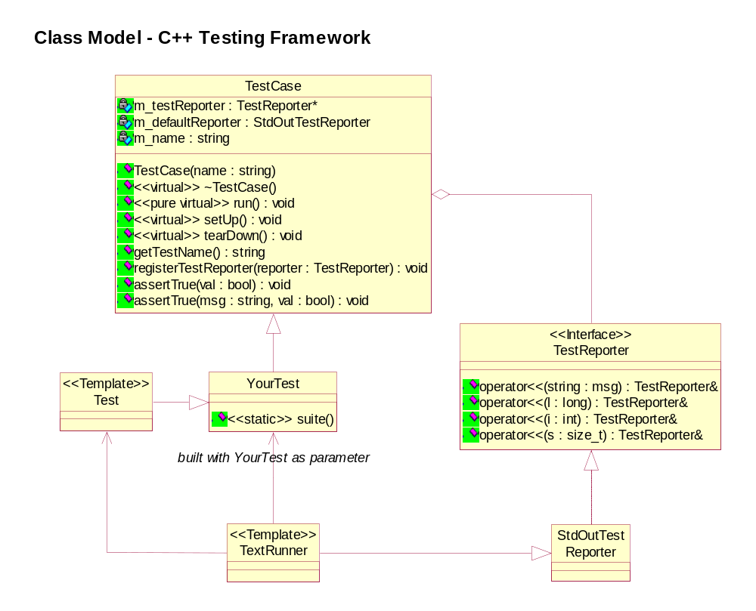
Figure 1: Class Model of the C++ Test Framework

The rest of this document is intended to provide an overview of developing test classes using the framework. The details of the implementation of the framework itself can be easily understood from inspection of the actual implementation code (it has, hopefully, been well documented within the implementation).

Using the Framework
As noted above the goal of the C++ Test Framework was to mimic the functionality of JUnit in a portable C++ framework (it has been tested on Windows and HP-UX). As with JUnit, the focus of developers using this framework is expected to be on creating the tests themselves and not on the framework in which they are executed. The framework is heavily based on templates, using templates allows for the type of dynamic definition and invocation that is available in Java through reflection. The details of the templates are provided in a later section of this doc.

The framework does place certain requirements on the development of unit tests in order to fit in to the framework – however, the overall impact of this is minimal. The following outlines the process of creating a new test case. The complete source code for the example used below can be found at the end of this document.

1. Create a class to contain your tests
Create a class to contain the set of tests to run. This new class should derive from TestCase, the base class for all test classes.

public class SampleTestCase : public TestCase

The constructor for your test class must be defined as follows:

SampleTestCase(string testName);

This constructor takes in the test name as a parameter and must be passed on to the base class TestCase constructor.

2. Optional: Override the setUp and teardown methods
As with JUnit, the framework provides a facility for performing common test initialization in a setUp method with corresponding clean-up in the tearDown method. These methods are called before and after a test is run respectively. Implementing these methods is optional.

3. Implement test methods
The primarily purpose of this class is to implement the actual tests themselves. The signature of a test must be the following:

void methodName(void);

Define and implement test methods as necessary. It is very important to note that each test must be autonomous – meaning they must stand on their own. This is because there is no guarantee of the order in which tests are executed. Also, each test is run in its own instance, so no two tests are run in the same instance (meaning that you cannot set a member variable in one test and expect to use it in another).

The implementation within the methods is whatever logic is required to perform the specific test. However, within the test it is important to know if the test is passing or failing. The verification of the tests occurs through the use of the assertTrue methods defined on the base TestCase. There are two implementations of this method:

void assertTrue(bool) throw (TestFail);
void assertTrue(string msg, bool) throw (TestFail);

Both of these methods use a boolean value to determine the result of the assertion with one of the API’s taking a message that can be used to provide details on the failure condition (this message will be reported out with the test failure). In the case the assertion fails, a TestFail exception is thrown to indicate to the framework that the test did not pass (this is important to so do not use a catch(…) in the body of your test method as this exception needs to be propagated back to the framework).

The following is an example test method:

void SampleTestCase::test1() throw (TestFail)
{
// perform your business logic
…
assertTrue("A does not equal B!", A == B);
}
There is one additional facility that can be used in testing to report tracing messages to help in debugging. The base TestCase has a report mechanism that can be used to provide these messages. The member variable m_testReporter can be used to write these messages. Use of this class is like the cout stream operator (this member variable is a pointer so it must be dereferenced before using):

*m_testReporter << “Some debug message” << “\n”;

3. Identify the test to run
In order to identify to the framework what tests to execute when running the tests for this class you must define a static method on your test class called suite. The signature must be the following:

static TestSuite suite();

The implementation of this method is where we get our first exposure to the templates that provide the power to the framework. In order to understand let’s take an example implementation of this method for our SampleTestCase:

TestSuite SampleTestCase::suite()
{
TestSuite tests;
tests.push_back(new Test<SampleTestCase>(&SampleTestCase::test1,
"Test Description 1"));
tests.push_back(new Test<SampleTestCase>(&SampleTestCase::test2,
"Test Description 2"));
return tests;
}

The template Test provides a mechanism for dynamically creating a subclass of your test case (in this example, SampleTestCase). This dynamic subclass is needed in order to provide a facility for defining and executing the method through the use of a function pointer as provided as a parameter to the constructor of this dynamic subclass. The second parameter provides a “friendly” name for the test that is used when reporting output about the test.

As noted in the discussion of implementing the test methods each method runs in its own instance of the test case. This is highlighted by the above as each test method gets registered with a different instance of Test<your test>.

The result of this method is the set of tests that should be executed by the runner (described below). Since the runner is also a template based class it is important that this method be defined as noted and defined as static. Otherwise, the template expansion of the runner class will fail.

4. Implement a main
In order to be able to run your tests you must define a main method that creates the appropriate test runner and tell the runner to run the test. The idea behind the runners is for providing flexibility in handling different output or reporting mechanisms. For instance, you could have a runner that writes to the console and another that is GUI based. Currently, only a console or text based runner has been developed.

The following is a sample main:

int main(int argc, char** argv)
{
TextRunner<SampleTestCase> runner;
runner.run();
}

The key to the above is the integration between the TextRunner and the suite method (which is expected to be implemented on SampleTestCase). The runner invokes the suite method to get the set of tests to execute and then iterates this list invoking the tests (well, calls setUp, invokes the test, calls teardown). The runner will track the success or failure of the tests and report the information to the output mechanism, which in this case is the console.

The runner also implemented the TestReporter interface so it can register itself with the tests to capture any debug or trace messages from the tests (this was how the TextRunner was implemented but is not a requirement for all runners).

That is all that is involved in creating and executing a test case within this framework.

Extending The Framework
As noted above, at this time only a console-based version of the framework has been created. A logical extension would be to provide a GUI based implementation of the runner (this was not done because of portability concerns, etc…). The key to providing such a facility would be to use the existing TextRunner template as a starting point (as can be seen from the template code there isn’t much to the implementation of this template).

Example Code
The following is an example implementation of a set of tests using this framework:

SampleTestCase.h
#ifndef __SAMPLETESTCASE_H__
#define __SAMPLETESTCASE_H__
#include "TestCase.h"
#include <string>
using namespace std;
class SampleTestCase : public TestCase
{
public:
SampleTestCase(string name);
virtual ~SampleTestCase(void);
// define our test method
void test1() throw (TestFail);
void test2() throw (TestFail);
void setUp();
static TestSuite suite();
protected:
};
#endif

SampleTestCase.cxx
#include "SampleTestCase.h"
#include "Test.h"
#include <vector>
using namespace std;
//-------------------------------------------------------------------
// Constructor - initialize what tests should be run
SampleTestCase::SampleTestCase(string testName)
: TestCase(testName)
{
}
//-------------------------------------------------------------------
// Destructor
SampleTestCase::~SampleTestCase(void)
{
}
//-------------------------------------------------------------------
// Defines the set of tests to run
TestSuite SampleTestCase::suite()
{
TestSuite tests;
// create a vector of tests to run - each test is created by wrapping it in
// our test template and defining a function pointer to the test to run.
// The second parameter is a "friendly" name that will be displayed when
// this test is run
tests.push_back(new Test<SampleTestCase>(&SampleTestCase::test1,
"Test Description 1"));
tests.push_back(new Test<SampleTestCase>(&SampleTestCase::test2,
"Test Description 2"));
return tests;
}
//-------------------------------------------------------------------
// Set-up routine, perform any initialization needed by the test
void SampleTestCase::setUp()
{
}
//-------------------------------------------------------------------
// Some test
void SampleTestCase::test1() throw (TestFail)
{
// perform some test functions - to verify the results use the assert
// methods to perform validations in the test. The asserts are used
// to trigger success and failures within the tests. You can also
// provide a descriptive message describing the condition around
// the assert failing
assertTrue("Test 1 should have passed!", true);
}
//-------------------------------------------------------------------
// Some test
void SampleTestCase::test2() throw (TestFail)
{
assertTrue("Test 2 should have passed");
}

Main.cxx
#include "SampleTestCase.h"
#include "TextRunner.h"
int main(int argc, char** argv)
{
TextRunner<SampleTestCase> runner;
runner.run();
}

